Web development assessment

Company details:
THE RENAL PROJECT is one of the India’s top company that provides the solution to dialysis patients. We are developing micro centers to reach dialysis patients even from the villages where hospitals are not present. Each microcenter consists of staffs who assists patients to make the dialysis process successful. We are growing exponentially to serve people and support human lives.
Problem statement:
To develop a web application that will be helpful for the staffs, admins and doctors to track the details about the patients and to provide dialysis
Workflow:
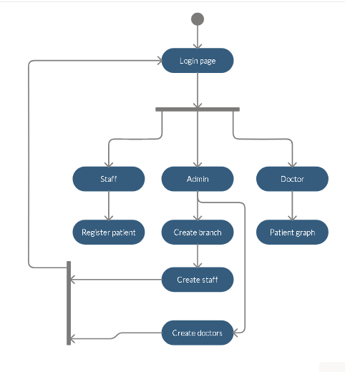
Description:
Developers are asked to build the following
- Develop a login page where the doctors, staff and admin can be able to login.
- Admin can able to create branches, doctors and admins. Inside the branch, staffs will be created. (Staffs are limited to branches where admins and doctors are not)
- Staffs can able to register the patients and provide dialysis. (There is no patient login)
- Doctors can view the registered patient’s graph. The graph should describe that the total number of patients registered per day and it should dynamically vary according to the registration done by staffs. (Example graph is shown below)

Example Graph:
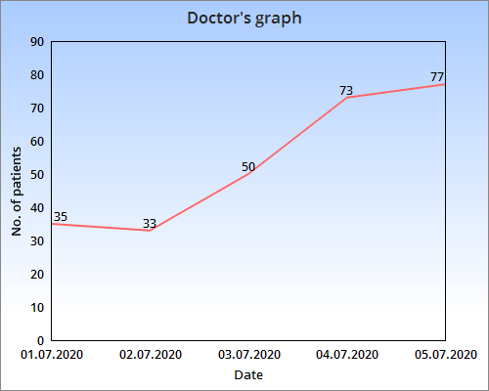

Required data:
- Adding new branch:
- Branch name
- Amount per patient
- Adding new staff, admin and doctor:
- Username
- Email & Password
- Phone number
- Adding new patient:
- Name
- Phone number
- AGE or DOB
Note: Developers are encouraged to add more parameters based on their creativity.
Expectation:
- Creativity
- Production ready implementation
- Very stable DB infrastructure
- Optimized backend code
Assessment will be based on the following:
- Clarity and efficiency of the solution
- Date of submission (Submission before the date will have added credits)
- Documentation
Submission:
The following items needed to be submitted
- Video Demo
- Deployed link (Not mandatory)
- Code

You can revert back with your web application before 20-09-2021 4:00PM. Kindly submit your assessment through email (teams@therenalproject.com). Please enclose the documentation that includes languages and frameworks used, DB used and other details with it. Submissions will not be accepted after 20-09-2021.
ALL THE BEST

